

UNIVERSITY OF PETROLEUM & ENERGY STUDIES
Dehradun

CONTINOUS INTEGRATION
AND
CONTINOUS DELIVERY

Experiment

Name: Rakshit Kapoor
Course: B. TECH CSE DevOps (2018-22)
Roll no.: R171218061
Sapid: 500068227

Experiment-4
Static Code analysis using SonarQube

Step-1: Go to sonarqube.org/download to download SonarQube.
Download the Community edition.
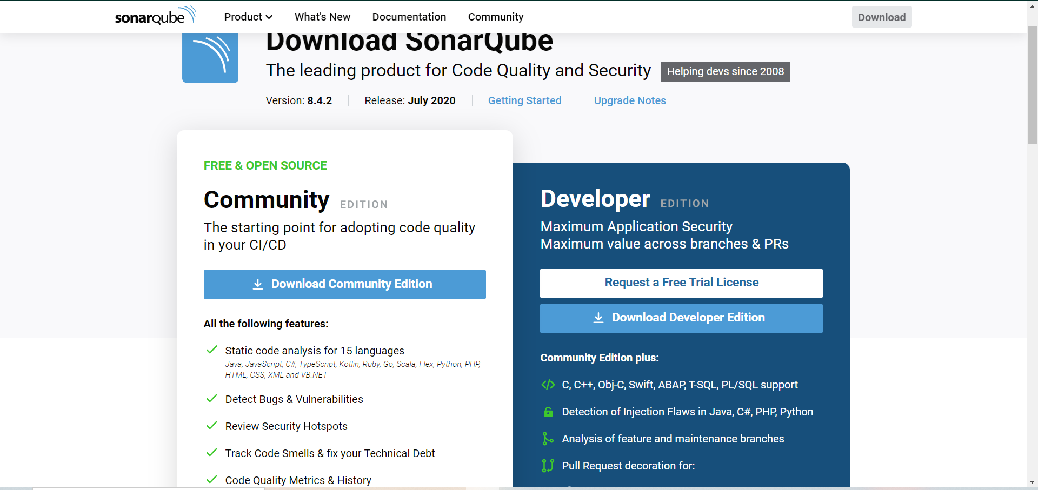

Step-2: Download is a zipped folder. Extract the folder.
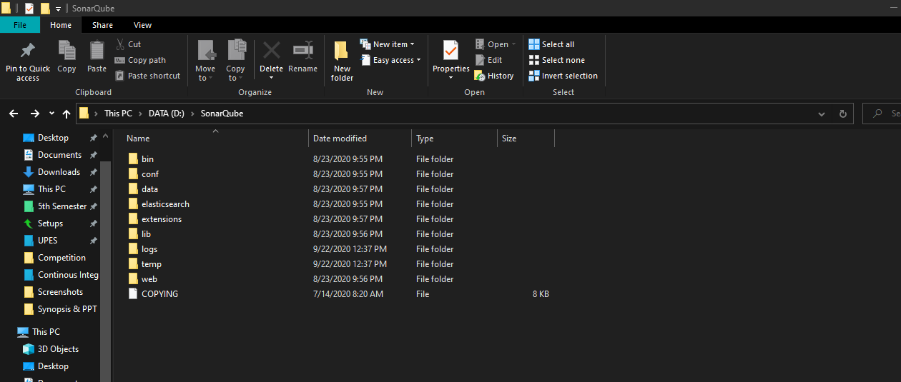
Step-3: use this path “bin\windows-x86-64” to go to the start sonar file

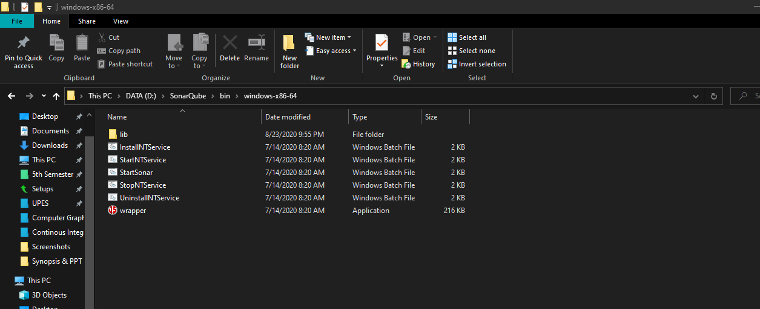

Step-4: type “StartSonar” to start SonarQube and type “localhost:9000” on the browser to start SonarQube.

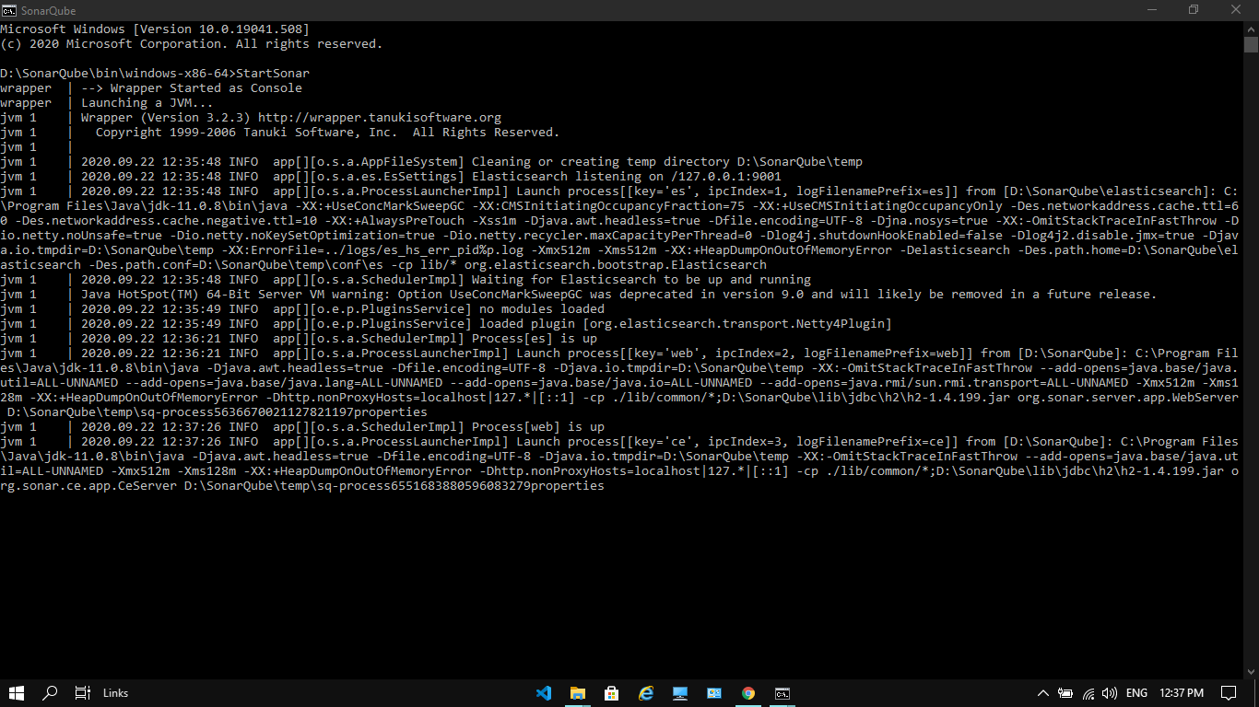

Step-5: Login to SonarQube and welcome window will appear.

